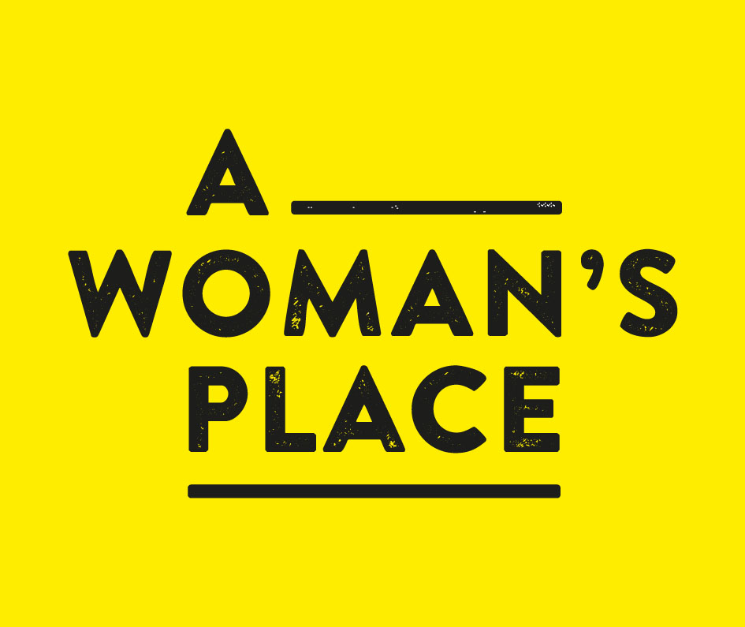
Job Description

A Woman’s Place
Education and Outreach co-ordinator
March 2017

A Woman's Place is a project, curated by Day+Gluckman, that aims to question and address the contemporary position of women in our creative, historical and cultural landscape. It is inspired by an urgent desire to relocate the simple message of female equality into the cultural fabric of today. Using historically significant venues, commissions and works will explore the relationship between a woman’s interaction with space and how changing society continues to affect and influence arts practice.
A Woman’s Place is supported using public funding by the National Lottery through Arts Council England, The National Trust, Trust New Art and other partners. In 2016 A Woman’s Place Project CIC (Community Interest Company) was formed to take forward the aims and ambitions of A Woman’s Place project as a constituted company.

The project will embrace contemporary art and discussion; commissions, conversations and action through a year of talks and events taking place across 2017, working with lead cultural organisations and Higher Education institutions in the South East, including New Hall Art Collection (Cambridge), Turner Contemporary (Margate), Royal Pavilion & Museums Brighton, Jerwood Gallery Hastings, Deal Town Hall, The Depot Lewes, University of Sussex and University of Brighton. Supporting partners also include Kent County Council and CVAN South East.

In 2018 the project will present five commissions that celebrate and uncover as yet largely untold lives and histories of women at Knole -with Vita Sackville West’s family home, lost to her through primogeniture (inheritance laws) and where Virginia Woolf based her extraordinary novel, Orlando (1928), most recently made into a feature film by Sally Potter 1992. The commissioned artists are CJ Mahony, Lindsay Seers, Emily Speed, Melanie Wilson and Alice May Williams. As the project progresses updates can be found on our website dayndgluckman.co.uk.

As part of the 2017 programme we are seeking a committed individual who will work in partnership across a range of people, projects and partners to co-ordinate, and ideally deliver, three workshops focused on enhancing community participation and engagement with A Woman’s Place in the South East. We are looking for someone who is a creative thinker, passionate about community collaboration and arts education and who has proven ability to build and maintain strong partnerships with community groups, support agencies and family networks with a view to increasing and develop on-going audience participation in the project.

We anticipate that the workshops will be delivered in West Kent. Lucy Day is based in Lewes, East Sussex and Eliza Gluckman is based in Brixton, London. Project meetings will be conducted remotely via Skype where face-to-face is not feasible. We would expect the co-ordinator to attend all the three workshops, ideally delivering them directly. We are currently also recruiting a Marketing Co-ordinator who would assist with promoting the workshops as part of the overall programme however the Education and Outreach Co-ordinator would need to demonstrate experience of identifying and marketing to a range of communities, and ideally will have experience of working with and supporting women and those identifying as women.

We are keen to hear from people with the following experience and skills:
- Experience working with community groups and people from a variety of backgrounds and ages
- Experience of workshop planning and delivery
- Experience managing potentially complex participants and behaviours
- Self-motivated, excellent communication skills, well-organised and efficient
- Co-facilitation experience
- A range of practical visual arts skills
- Familiar with working independently and using remote working tools, for example Skype/Google Hangouts and Dropbox

Fees
We have a fee of £ 4,800 for 12 months work based c. 16 hours/month plus additional travel costs to be agreed. The fee includes all liable tax and National insurance contributions.
All practitioners will be employed on a freelance basis, responsible for their own Tax and National Insurance and must have an up to date DBS check.

Timetable for delivery
Starting April 2017, ending March 2018.

Application process
Please provide a written proposal as a combined PDF (up to four sides A4) to include:

- Your approach to how you might identify relevant community groups and deliver the three workshops
- Current CV with examples and links to projects that demonstrate relevant experience to be part of the CV. (No further attachments)
- Contact details of two relevant referees

Please email your proposal to mail@dayandgluckman by 5pm on 31st March 2017
Please be prepared to be interviewed online if possible (Skype or Googlechat) if your application is successful.

Day+Gluckman/A Woman’s Place Project CIC is committed to diversity and equal opportunities. We endeavour to ensure that all applicants are treated fairly, and we welcome applications from all sections of the community. We are particularly interested in hearing from parents with caring responsibilities who are looking to re-enter the workplace on a flexible basis.
Please let us know if you require this information in a different format, or would be unable to be interviewed online.

www.dayandgluckman.co.uk

